**Assignment C Program**

**Subject Programming fundamental Submitted by Rimsha Jameel**

**Submitted to**

**Dr. Shafiq**

**Class**

**BS(CS)**

**Semester**

**1ST**



**The sum of first 10 numbers using while loop**

#include<stdio.h>

#include<conio.h>

main()

{

int a=1,sum=0;

while(a<=10)

{

sum=sum+a;

printf("%d\n ",a);

a++;

}

printf("Sum = %d ",sum);

getch();

}

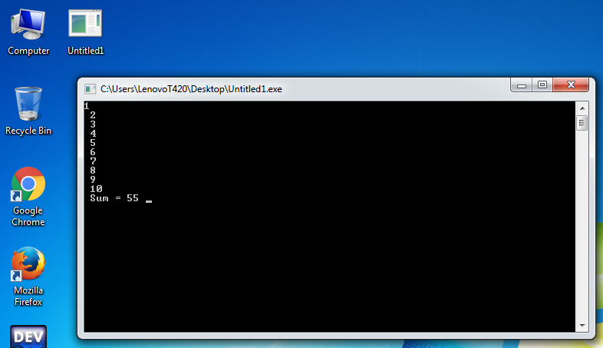

**The sum of first 10 numbers using Do while loop.**

#include<stdio.h>

#include<conio.h>

main()

{

int a,sum=0;

a=1;

do

{

printf("%d\n",a);

sum=sum+a;

a++;}

while(a<=10);

printf("sum=%d",sum);

getch();

}

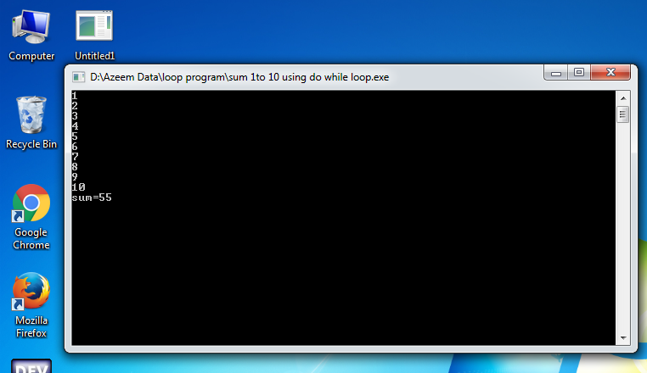

**The sum of first 10 numbers using for loop.**

#include<stdio.h>

#include<conio.h>

main()

{

int a,sum=0;

for(a=1;a<=10;a++)

printf("%d\n",a);

sum=sum+a;

printf("Sum = %d",sum);

getch();

}



**The factorial of a number using while loop.**

#include<stdio.h>

#include<conio.h>

main()

{

int a,f,b;

printf("Enter a number: ");

scanf("%d",&b);

f=1;

i=1;

while(a<=b)

{

f = f *a ;

a++;

}

printf("Factorial: %d",f);

getch();}

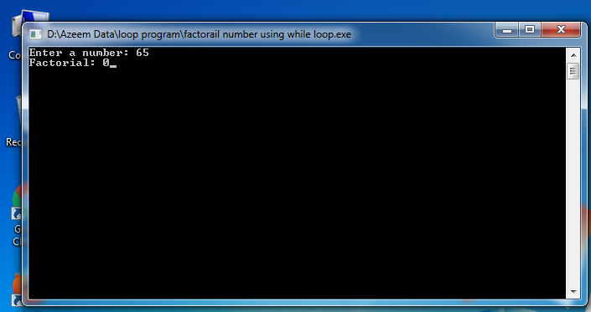

**The factorial of a number using do while loop.**

#include<stdio.h>

#include<conio.h>

main()

{

int a,b,f;

printf("Enter the number");

scanf("%d",&b);

f=1;

a=1;

do

{

f=f*a;

a++;

}

while(a<=b);

printf("Factorail is %d :",f);

getch();

}

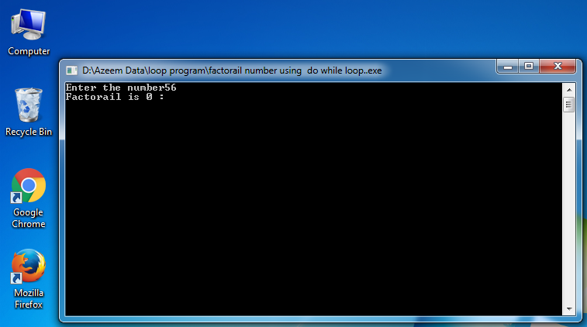

**The factorial of a number using for loop**

#include<stdio.h>

#include<conio.h>

main()

{

int a,b,f;

f=1;

printf("Enter the number ");

scanf("%d",&b);

for(a=1;a<=b;a++)

f=f*a;

printf("Factorail is %d :",f);

getch();

}



**Reverse number using while loop**

#include <stdio.h>

#include<conio.h>

int main()

{

int n, reverse=0, rem;

printf("Enter an integer: ");

scanf("%d", &n);

while(n!=0)

{

rem=n%10;

reverse=reverse*10+rem;

n/=10;

}

printf("Reversed Number = %d",reverse);

getch(); }

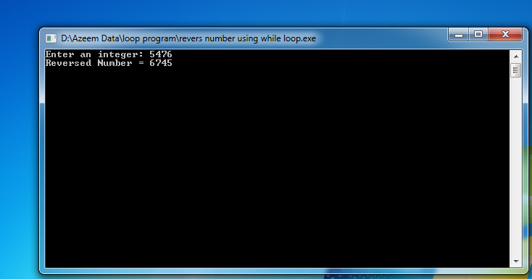

**Reverse number using do while loop**

#include<stdio.h>

#include<conio.h>

main()

{

int rn,n;

printf("enter a number");

scanf("%d",&n);

do

{

rn=n%10;

printf(" %d",rn);

n=n/10;}

while(n!=0);

getch();}



**Reverse number using for loop**

#include<stdio.h>

#include<conio.h>

main()

{

int rn,n;

printf("enter a number\n");

scanf("%d",&n);

for(n=n;n!=0;n=n/10)

{

rn=n%10;

printf("%d",rn);}

getch();}



**The sum of digits of a number using while loop**

#include<stdio.h>

#include<conio.h>

main()

{

int a, s;

printf("Enter value of a: ");

scanf("%d",&a);

s = 0;

while(a > 0){

s = s + (a%10);

a = a / 10;}

printf("Sum of digits: %d",s);

getch(); }

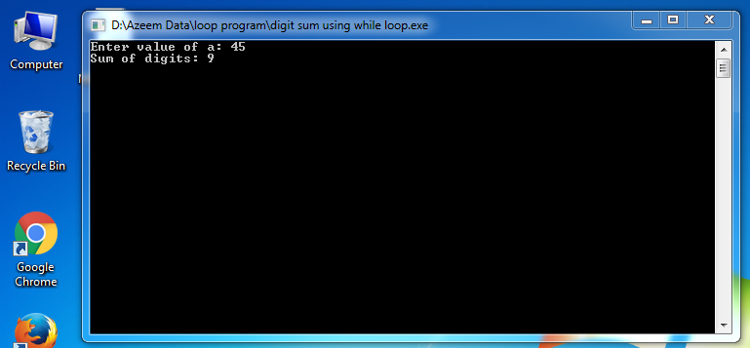

**The sum of digits of a number using do while loop**

#include<stdio.h>

#include<conio.h>

main()

{

int a, s;

printf("Enter value of a: ");

scanf("%d",&a);

s = 0;

do{

s = s + (a%10);

a = a / 10;}

while(a > 0);

printf("Sum of digits: %d",s);

getch();}



**The sum of digits of a number using for loop**

#include<stdio.h>

#include<conio.h>

main()

{

int a, s;

printf("Enter value of a: ");

scanf("%d",&a);

s = 0;

for(s=1;a>0;s=s+(a%10))

a = a / 10;

printf("Sum of digits: %d",s);

getch(); }



**The table of 2 up to 10 using while loop**

#include<stdio.h>

#include<conio.h>

main()

{

int a,b,c;

a=1;

b= 2;

while(a<=10)

{

c=b*a;

a++;

printf("%d\n ",c);}

getch();}

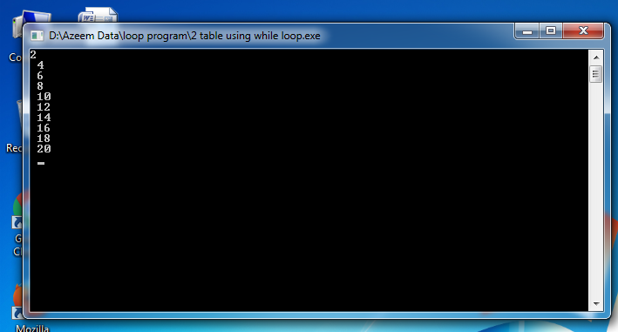

**The table of 2 up to 10 using do while loop**

#include<stdio.h>

#include<conio.h>

main()

{

int a,b,c;

a=1;

b=2;

do{

c=b*a;

a++;

printf("%d\n",c);

}while(a<=10);

getch();}



**The table of 2 up to 10 using for loop**

#include<stdio.h>

#include<conio.h>

main()

{

int a,b,c;

b=2;

for(a=1;a<=10;a++)

{

c=b*a;

printf("%d\n",c);}

getch();}



**Sum the series 1+ 2 + 4 + 6 + 8 + 10 +12 +14 + 16 + 18 + 20 using while loop**

#include<stdio.h>

#include<conio.h>

main()

{

int a,sum;

a=1;

sum=0;

sum=sum+1;

while(a<=20)

{ a++;

printf("+%d\ ",a);

sum=sum+a;

a++; }

printf(" =Sum is %d",sum);

getch();}

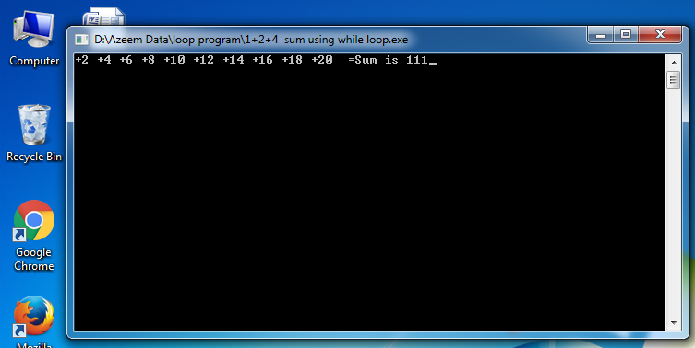

**Sum the series 1+ 2 + 4 + 6 + 8 + 10 +12 +14 + 16 + 18 + 20 using do while loop**

#include<stdio.h>

#include<conio.h>

main()

{

int a,sum;

a=1;

sum=0;

sum=sum+1;

do

{

a++;

printf("+%d\ ",a);

sum=sum+a;

a++; }

while(a<=20);

printf("=Sum is %d",sum);

getch(); }



**Sum the series 1+ 2 + 4 + 6 + 8 + 10 +12 +14 + 16 + 18 + 20 using for loop**

#include<stdio.h>

#include<conio.h>

main()

{

int c,r=1;

for (c=1;c<=20;c=c+2)

printf("+%d\ ",c);

r=r+c;

printf("= sum is %d",r);

getch();

}



**Sum the series 1! +2! + 3! + 4! + 5! + 6! +7! +8! + 9! + 10! Using while loop**

#include<stdio.h>

#include<conio.h>

main()

{

int a,f,sum;

a=1;

f=1;

while(a<=10){

printf("%d",a);

f=f*a;

a++;

sum=f+a;

printf("!=%d\n",f); }

printf("Sum factorail is : %d",sum); getch();

}

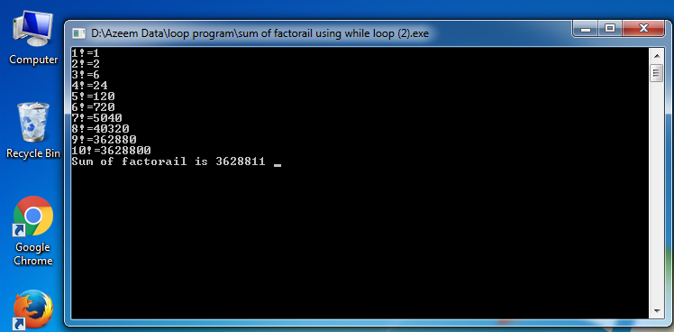

**Sum the series 1! +2! + 3! + 4! + 5! + 6! +7! +8! + 9! + 10! Using do while loop**

#include<stdio.h>

#include<conio.h>

main()

{

int a,f,sum;

a=1;

f=1;

do{

printf("%d",a);

f=f*a;

a++;

sum=f+a;

printf("!=%d\n",f); }

while(a<=10);

printf("Sum of factorail is %d ",sum);

getch(); }



**Sum the series 1! +2! + 3! + 4! + 5! + 6! +7! +8! + 9! + 10! Using for loop**

#include<stdio.h>

#include<conio.h>

main()

{

int a,f,sum;

f=1;

for(a=1;a<=10;a++)

{

printf("%d",a);

f=f*a;

sum=f+a;

printf("!=%d\n",f);}

printf("Sum of factorail is %d",sum);

getch();

}

